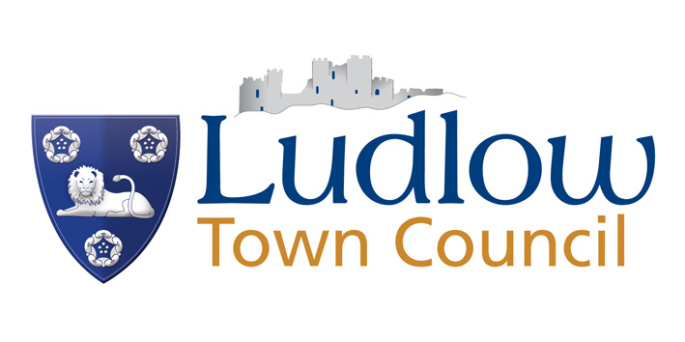

DEBT RECOVERY POLICY

Invoices are raised for sundry income due to the authority.
All staff must raise orders for goods and services as orders are placed and to settle invoices promptly after the goods have been received or the service has been provided.
We aim to raise invoices for monies due to the Council as soon as practicable to maximise the Council’s cash flow.
Cash flow for Market traders is managed by the Market Manager who will ensure that there is no more than a three week recovery period before action is taken by way of letters before action and if necessary to terminate the Licence agreement and take legal proceedings.
Invoices can be raised up to the statutory limit of six years from the date the service was provided.
Invoices that remain unpaid pass through an automatic recovery process of reminders and letters and are then passed to an external Solicitor to commence legal recovery.
A 2% charge per month will be imposed on all unpaid invoices outside the 28 day payment period.
In cases of hardship, arrangements can be made for payment of an invoice in instalments. Instalment plans for a period of more than 6 months may be agreed in certain circumstances, but will only be authorised once the customer has completed and returned an application form making a suitable commitment to the satisfaction of the Town Clerk.
Policy and Finance Committee will receive a list of all the Council’s outstanding debts each time a meeting is held.

